LAB 7 Vulkan

Introduction
In the final lab assignment, you will explore techniques required to render GLTF models at a higher fidelity. You will start by loading an official GLTF test model with a more complex PBR material. You will then adapt your drawing code to accurately/correctly render models by accounting for the standard (right-handed) GLTF coordinate system.
From there you will adapt your Z buffering code to handle a wider range of depth variation without visual artifacts. This technique is extremely helpful for games that render large environments & distant vistas.
To round out your understanding of common material textures, you will load both normal & emissive maps. Then use their data to influence the lighting equations from your shaders. This culminates with you loading an image-based lighting (IBL) cube map and using it to integrate a highly realistic PBR pixel shader.

LAb 7

SECTION A | 25% - ProjeCT Setup: model SWAP, RIGHT-HANDED Coordinate SYSTEMS

Task A1
Copy Lab 6 as your base, and switch to using the Bottle GLTF model. (Don’t forget to export it from Blender first)
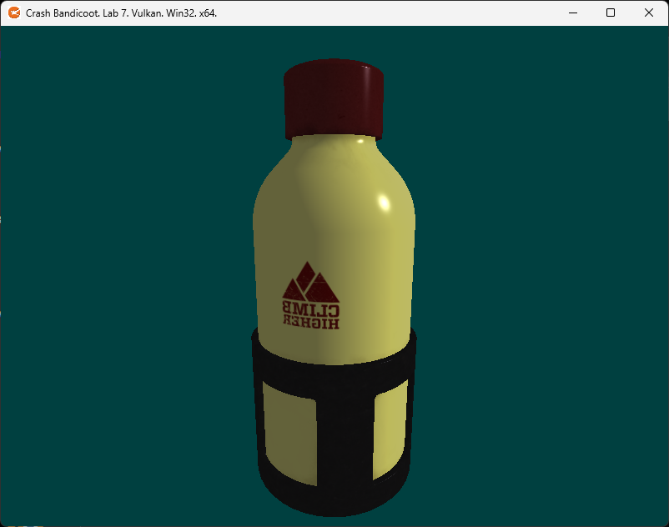
Note the text on the bottle is backwards… This is due to a major issue we have been avoiding up till this point.
Hint: Don’t forget to adjust the CMakeLists.txt to correctly name the project after copying your source over.

Task A2
We are currently using a left-handed coordinate system, whereas GLTF uses a right-handed coordinate system. We have two choices here: Conform our coordinate system to GLTF’s system or adjust the incoming matrix/transform data and geometric winding to account for the difference.
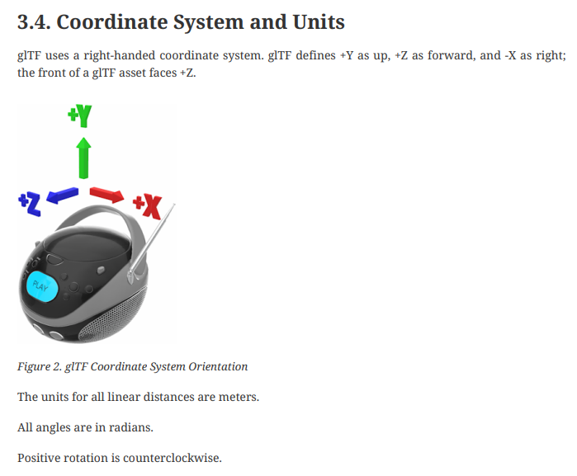
The simplest way to make a GLTF model a left-handed model is to scale it -1 on the Z axis. (see above image)
Now is a good time to add support for world matrices to the project like you did in Lab 4 via storage buffers. Alternately, you can add one world matrix to the SHADER_VARS before sending it to the shader as a temporary solution. (however, be aware this will only work for a single mesh and limits the complexity of loadable models)

Task A3
Regardless of which method you choose, create a World Matrix that flips the 3D model around the Z axis. Apply this new matrix by adjusting your vertex shader. After scaling on the -Z axis, the model will look like this:
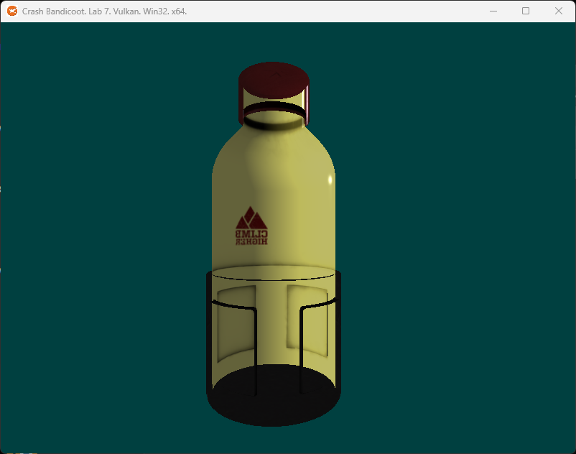
The final issue is that (as mentioned in the previous image) the GLTF coordinate system causes positive rotation to be considered counterclockwise. This means that based on our current rasterizer settings, only clockwise triangles will be rasterized.

Task A4
To fix this, we must find where the front face setting is selected and set it counterclockwise, so Vulkan knows to render those faces instead of the other way around. (this is part of the rasterization pipeline settings)
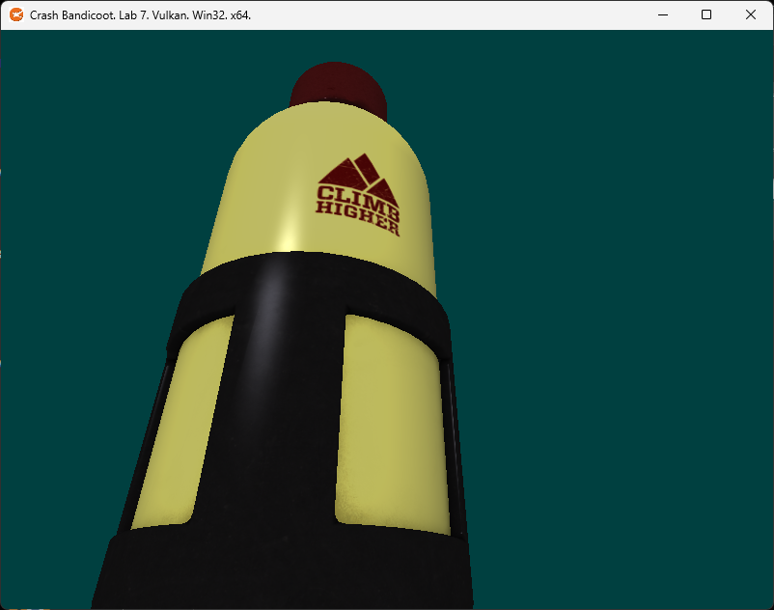
Once you incorporate the -Z world matrix and culling mode swap, the model should look correct. Don’t forget to also move multiply the vertex normal by the new world matrix. If you don’t, the lighting will start acting strangely. You may see artifacts like specular highlights in the shaded areas of the model where they don’t belong.

LAB CHECKPOINT | MANUAL COMMIT | DO NOT SKIP
To receive credit for your assignments, you must manually commit to your Repo 4 times (Once at the end of each Part/Section). If you skip this commit (or disable auto commits) you will not receive credit for the previous section.
- Change the lab’s Title Bar so it says where you are in the lab.
  - For Example: “John Smith – Lab 1 – Part 1 Complete”
- Take a Screenshot of the lab window running showing your work. (Windows Key + Shift + S)
- On Windows the screenshot is in your clipboard, open MS Paint and (Ctrl + V) to load it in.
- Save the image with the same name as your title bar in the root folder of this repository.
- Open GitHub Desktop for this repo. You should see the new image as a pending change.
- Create a commit message with the same name as the title bar & commit your changes.
If this section is not perfect but you need to continue forward, you must still do this to get partial credit!

section B | 50% - ENHANCING Z BUFFER PERCISION

Task B1
Change the near plane so it is at 0.00001f and the far plane to 10000.0f
Move the camera away from the bottle and you should start to see the Z buffer’s accuracy start to break down:
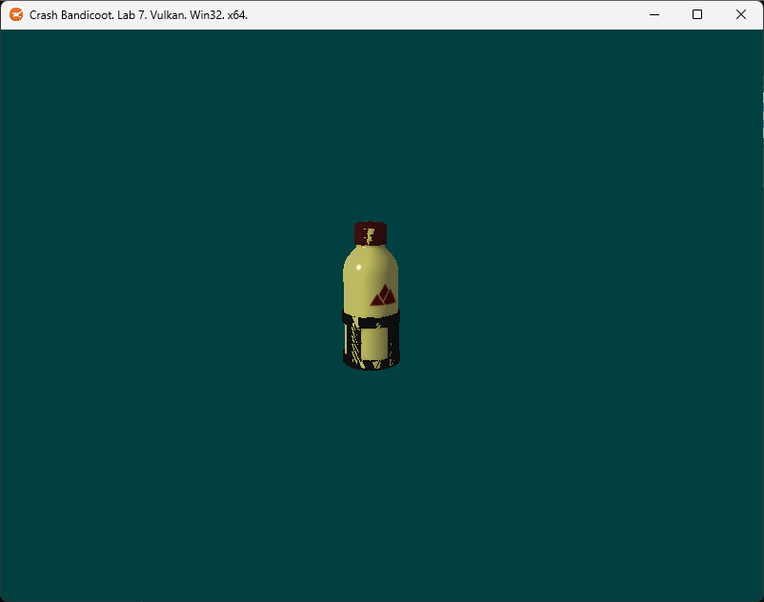
Why this happens and how we can improve it: https://developer.nvidia.com/content/depth-precision-visualized

Task B2
It’s fair to say these are extremely aggressive distance thresholds we are asking from our Z Buffer (Particularly the Near Plane). And while a single bottle doesn’t need this level of depth range, a giant 3D model representing an entire game level/world probably would.
The good news is we can get a more usable curve to our depth buffer precision by reversing our Z depth:
- Clear the Z buffer to 0 not 1. (0 is now the Far Plane)
- In the Depth Stencil State swap the min/max Depth Bounds. (0 1)
- Switch the Z comparison mode to GREATER instead of LESS_THAN.
- In the Viewport, swap the min/max Depth values. (0 1)
  - Swapping the Near/Far of the projection matrix can achieve the same result if required.
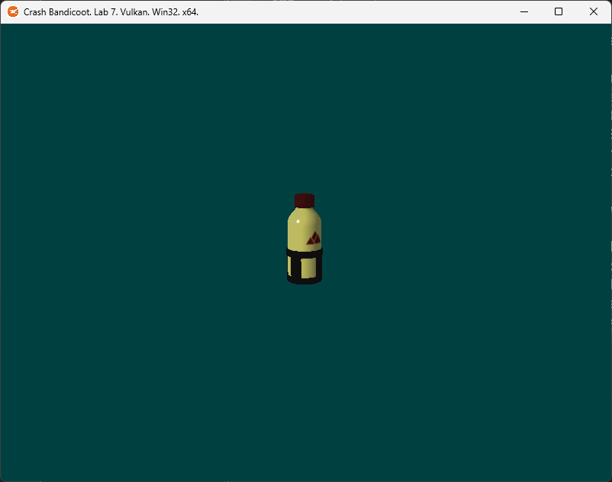
Tip: This technique is how many modern games do much farther draw distances than they could in the past.

Task B3
Use your understanding of vector/matrix math to rotate the light’s direction around the model slowly over time:
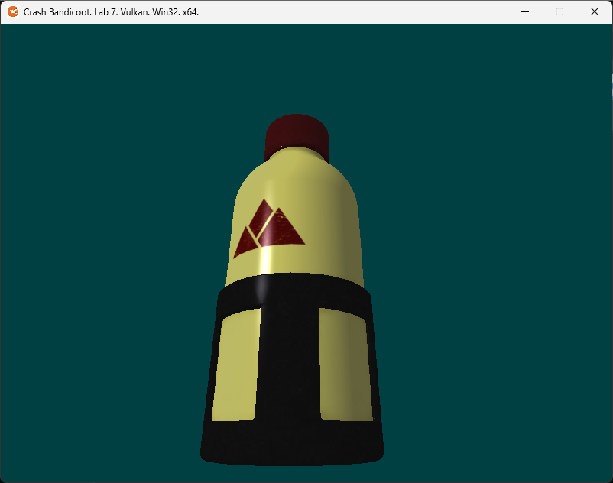
I did this by tracking the elapsed seconds since the start of the program. I then used that time to rotate a temp matrix on the Y axis by interpreting time as radians. I then rotated the sun’s original direction by that matrix.
Our project is fully set up for rendering precise GLTF geometry. Now let’s incorporate those remaining textures!

LAB CHECKPOINT | MANUAL COMMIT | DO NOT SKIP
To receive credit for your assignments, you must manually commit to your Repo 4 times (Once at the end of each Part/Section). If you skip this commit (or disable auto commits) you will not receive credit for the previous section.
- Change the lab’s Title Bar so it says where you are in the lab.
  - For Example: “John Smith – Lab 1 – Part 1 Complete”
- Take a Screenshot of the lab window running showing your work. (Windows Key + Shift + S)
- On Windows the screenshot is in your clipboard, open MS Paint and (Ctrl + V) to load it in.
- Save the image with the same name as your title bar in the root folder of this repository.
- Open GitHub Desktop for this repo. You should see the new image as a pending change.
- Create a commit message with the same name as the title bar & commit your changes.
If this section is not perfect but you need to continue forward, you must still do this to get partial credit!

section C | 75% - USING NORMAL & EMISSIVE MAPS

task C1
Load the normal and emissive maps from the first material in the GLTF file.
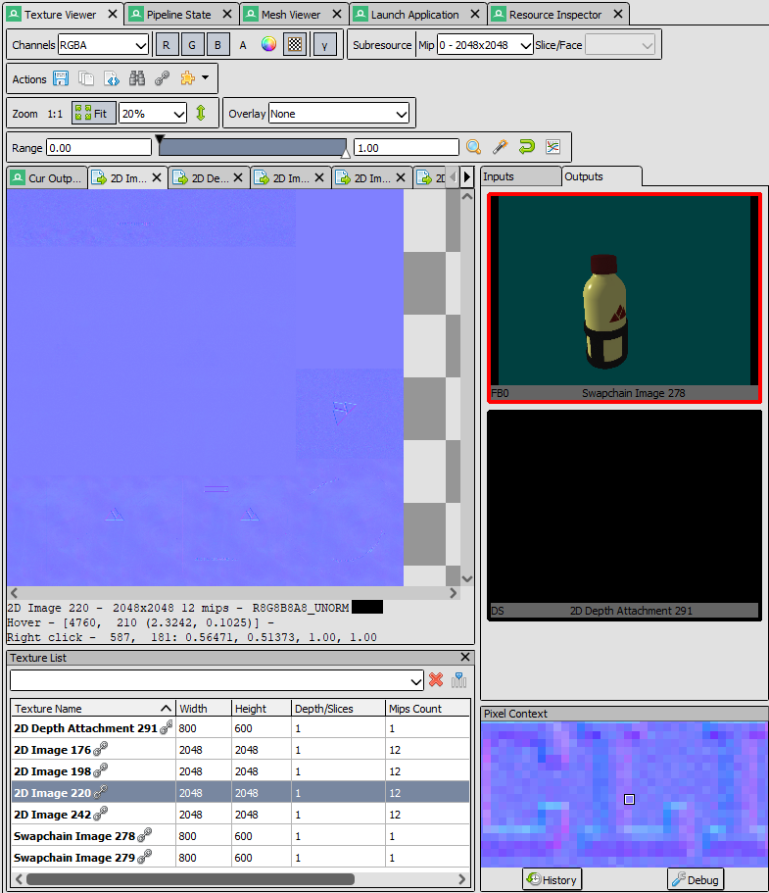
You can see the normal map is mostly flat (Purple) but there are some spots where the normal data seems to indicate that the logo has been embossed into the metal of the bottle. Also note the surface of the dark grey metal has more normal variation which indicates it is less smooth.
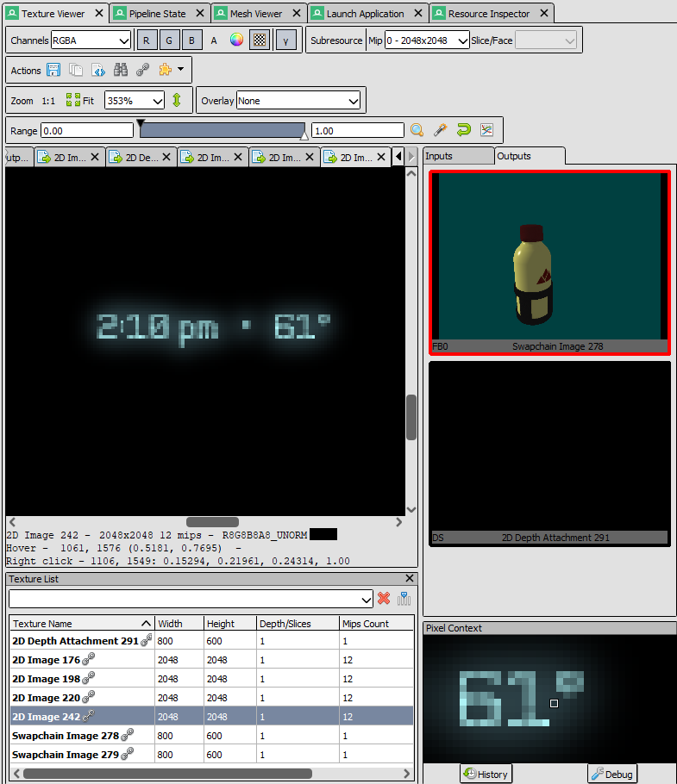
The emissive map is mostly empty unused space. However, if you zoom in you can see there is a small section with some numbers/writing. This seems to be a glowing LED indicator built into the bottle. This appears to be the only part of the bottle that emits its own light/glows.

task C2
In the Vertex Shader, multiply the incoming tangent vector into World Space.
IMPORTANT: The tangent vector is a direction not a position. The W component is used to determine the polarity of the tangent relative to the surface based on the UV data. It’s essentially always just 1 or -1 and gets used later.
This means you must preserve the value of W, but it cannot affect the transformation of the 3D vector/direction. Treat the tangent like you would a vertex normal, then restore the W and send it to the Fragment Shader.

task C3
In the Fragment Shader, normalize the incoming tangent vector (XYZ only). Compute a new 3D vector called the binormal by crossing the surface normal with the tangent vector (Both in World Space).
Scale this new binormal by the tangent’s W value you preserved from the Vertex Shader. (Flipping it if required)

task C4
We now have everything we need to create something called the Tangent Binormal Normal matrix. (TBN)
This is a 3x3 Matrix used to transform any normal we read from the normal map into the World Space of the triangle we are currently rasterizing.
Create the TBN matrix like so:
ROW 1 = [Tangent]
ROW 2 = [Binormal]
ROW 3 = [Normal]
NOTE: You may wonder why we don’t just store tangents in object/world space to begin with. This would be fine for static 3D models; however, many 3D models have animations that distort the placements of triangles over time. By keeping the normal data relative to the triangles, we account for any dynamic changes to the overall topology.

task C5
Now that we have our TBN matrix, we can use it to calculate a significantly more detailed per-pixel normal found in the normal map texture. Retrieve the final surface normal like so:
- Sample the XYZ color from the Normal Map at the current UV location.
- Scale the normal map color by 2x so it ranges from 0.0f – 2.0f (instead of 0.0f – 1.0f).
- Subtract 1.0f from all components of the resulting vector so the range shifts to -1.0f to +1.0f.
- Use the TBN matrix to transform the resulting triangle localized normal into World Space.
Once you have this new pixel-based normal vector, use it in all your lighting and shading calculations:
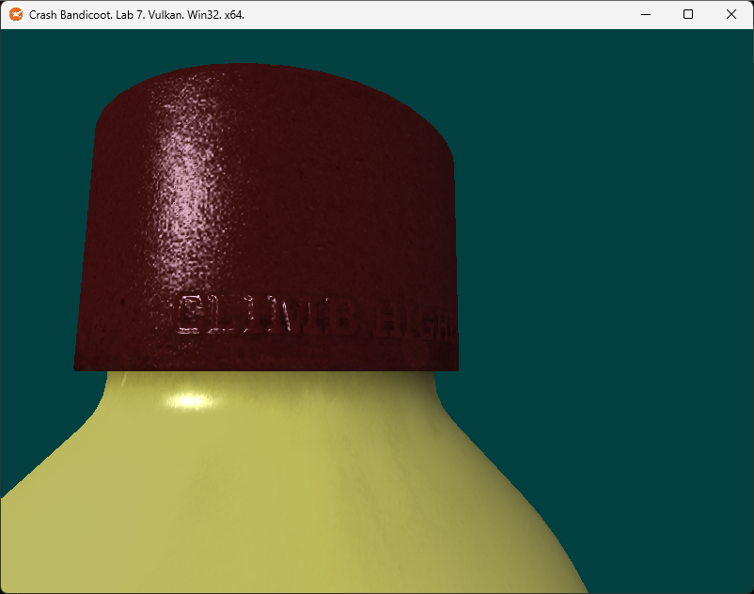
Once you incorporate the normal derived from the normal map in the directional lighting algorithm (instead of the existing vertex normal). You should see a rather stark change in lighting/surface detail.
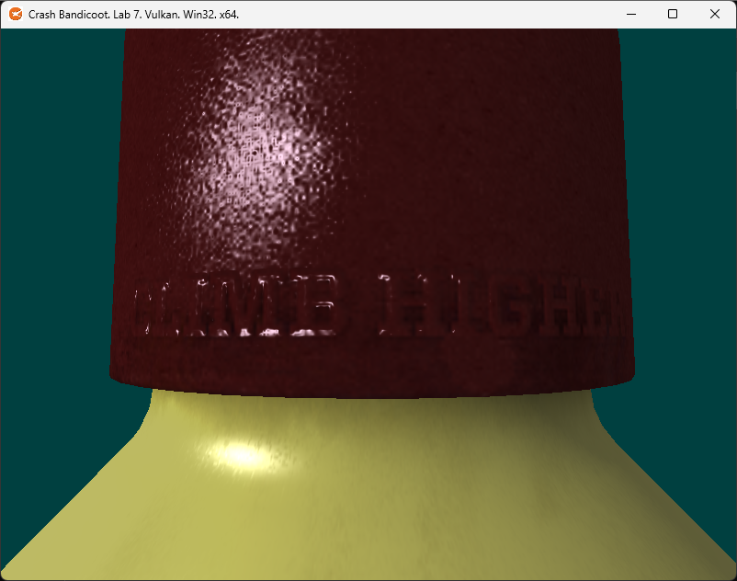
If you slow down the light rotation & study the behavior, you will notice that the top of the letters in the normal map are not being lit up. This is an issue because the green channel in the normal map indicates that those surfaces should be getting lit up by our light shining from above when it passes over them:
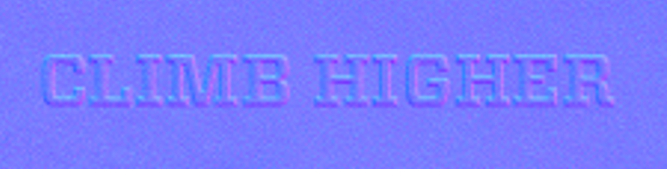
This happens because the normal maps used in GLTF models are OpenGL style normal maps. In these maps, green means up or +Y in the normal map. In DirectX style normal maps, green instead means down or -Y. Again, this difference is mainly due to the right-handed vs. left-handed coordinate systems where these Normals will be used.
Adjusting for this is quite simple:
Just invert (not negate) the value of the green channel after it is loaded from the normal map texture but before you shift its range and multiply it by the TBN matrix. (ex: green = 1.0 – green)
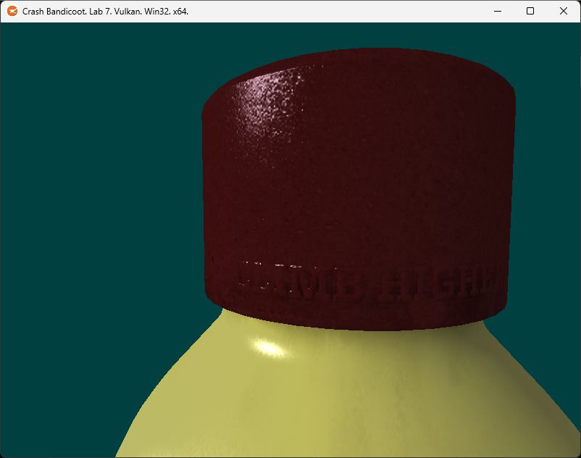
Once you do this, you should see the tops of the letters and other raised/embedded surfaces properly react to the directionality of the light source. As you can see, normal mapping makes a pretty big difference in the perceived detail/complexity of a surface. (As long as the user doesn’t look too closely of course!)

task C6
Use the emissive map to add light/glow to the surface. Thankfully this is much easier to integrate than the normal map was. Just load the texel from the emissive map and simply add it to the final formula that combines all the other aspects of the light & material:
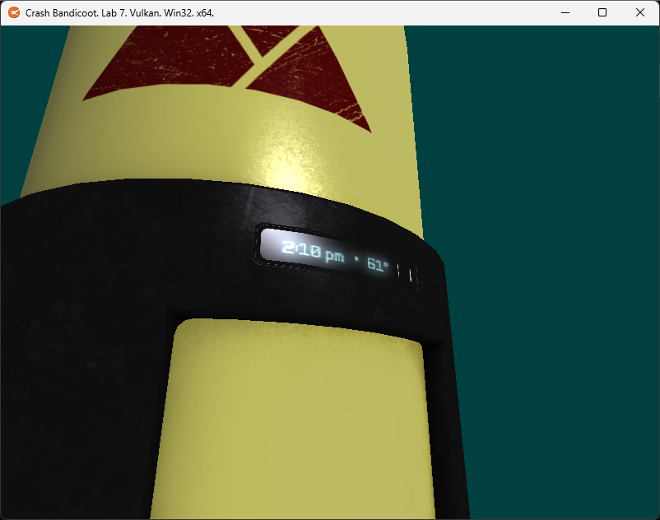
Our LED display embedded behind glass. Note how it continues to glow even when the light does not hit it directly.
Nice work! You now have a running example of classic materials in action. Games used these types of materials for a very long time. We will end our formal study of graphics by bumping things up to Physically Based Materials next.

LAB CHECKPOINT | MANUAL COMMIT | DO NOT SKIP
To receive credit for your assignments, you must manually commit to your Repo 4 times (Once at the end of each Part/Section). If you skip this commit (or disable auto commits) you will not receive credit for the previous section.
- Change the lab’s Title Bar so it says where you are in the lab.
  - For Example: “John Smith – Lab 1 – Part 1 Complete”
- Take a Screenshot of the lab window running showing your work. (Windows Key + Shift + S)
- On Windows the screenshot is in your clipboard, open MS Paint and (Ctrl + V) to load it in.
- Save the image with the same name as your title bar in the root folder of this repository.
- Open GitHub Desktop for this repo. You should see the new image as a pending change.
- Create a commit message with the same name as the title bar & commit your changes.
If this section is not perfect but you need to continue forward, you must still do this to get partial credit!

section D | 100% - Physically based rendering (PBR SHADERS)

OVERVIEW
Fully comprehending all the math behind what a PBR Shader does is a bit beyond the scope of what we can do in the last part of the last assignment of a single month course.
However, the good news is that we should have all the tools needed to integrate such a shader into our code base. For this last section we will be loading three special textures and then switching over to a pre-written PBR shader.
If you wish to learn more about PBR in greater depth, I suggest reading these articles:
http://www.codinglabs.net/article_physically_based_rendering.aspx
http://www.codinglabs.net/article_physically_based_rendering_cook_torrance.aspx

task D1
From the provided PBR IBL ENV folder, load the lut_ggx.png texture file into your existing texture array:
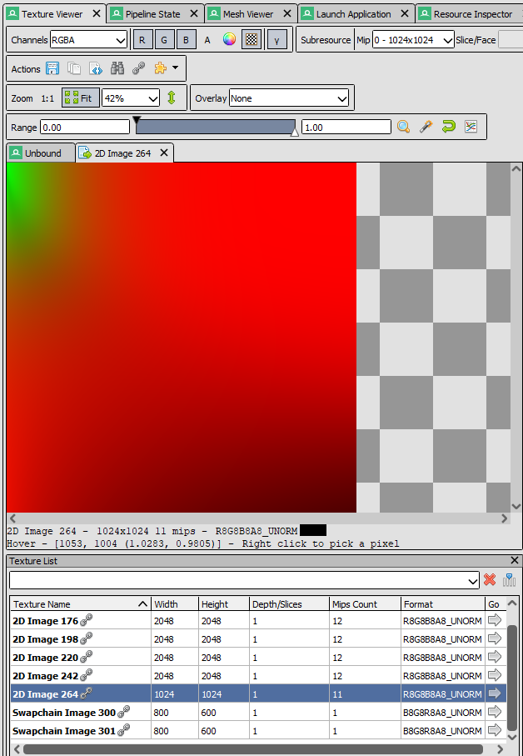
The PBR shader will use this to help calculate the proper split-sum approximation for Cook-Torrence specular.

task D2
Ok… one down two more to go. The next two files are not your normal run of the mill texture formats. They are something known as cube maps and are 6 images forming a hollow box. Most standard image formats cannot represent this style of texture. (BTW, this is also the type of format used for a SkyBox/Environment map in games)
To Load these textures, you will need to link the ktx texturing library included in this lab assignment. Inside the ktx folder you will find README.txt that explains how to link the library into your project/CMakeLists.txt and what headers to include in your code.
Once you do this. You should be able to include & compile the provided TextureUtilsKTX.h header file.

task D3
With the library code working, let’s try it out by loading the diffuse.ktx2 cube map image using our new utility function in TextureUtilsKTX.h. Load the file and add it to the existing texture vector you have already been using:
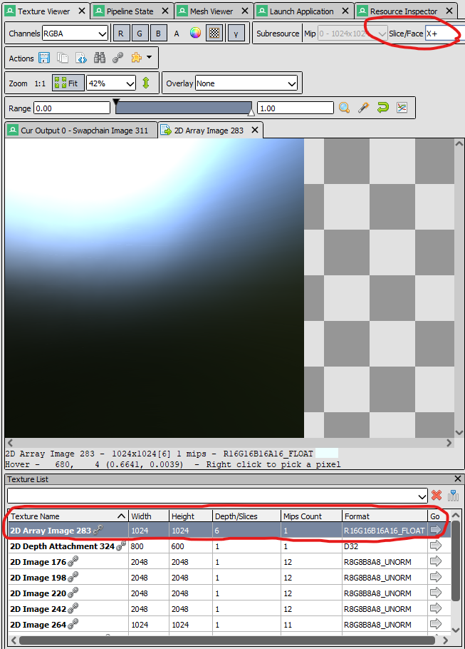
Make note of the fact that this texture has multiple slices and a 16bit floating point format per channel. Try clicking on the slice/face drop down menu in the top-left corner to see the different cube faces.
Even though this is technically a different type of texture (a cube map) it can still be loaded into the main texture array we already have. Normally we would need to go mess with descriptor sets, but thankfully we are using BINDLESS texturing which lets us bypass that previous requirement. (love bindless!)

task D4
Same deal as before. Load the specular.ktx2 cube map texture and verify its presence using RenderDoc:
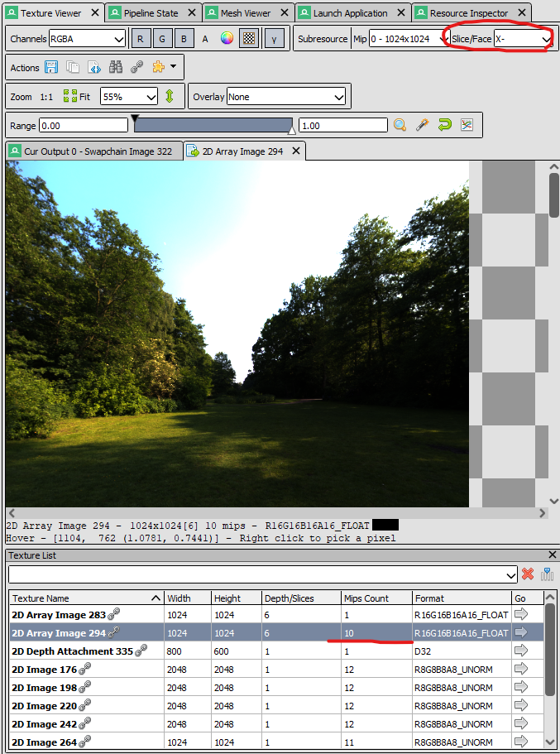
Notice that the Specular IBL (Image Based Lighting) texture in PBR is much more legible than the diffuse version. This makes sense since this cube map is the source of things like clear metallic reflections vs. diffused/scattered ambient light/energy.
However, this only stays crystal clear for the first Mip level [0]. If you check the lower levels, you will see how the sampled reflection gets more and more scattered. This is because something like brushed metal still reflects its surroundings but due to the roughness of the surface, reflected rays are not always parallel in proximity.

task D5
Ok… we have everything we need. Switch your pipeline over to using the FragmentShader_PBR.hlsl shader. This shader has been fully set up to work with all the data you have recently loaded and are sending from the vertex shader. It is very likely that it won’t work immediately without a few tweaks since our code may be a bit different.
Take careful note of which textures are in your texture array vs. the order I am using them in the shader. You may also need to adjust the incoming vertex format and SEMANTICS to match whatever your Vertex Shader is currently sending as output to the Pixel/Fragment stage:
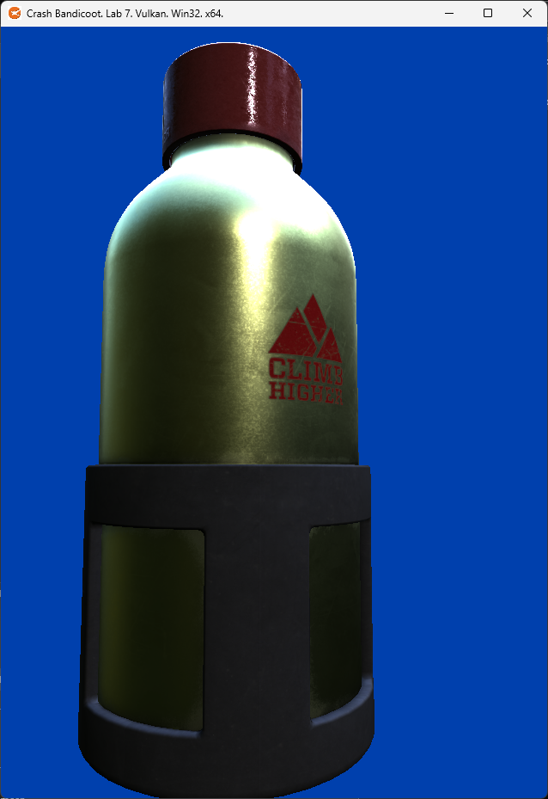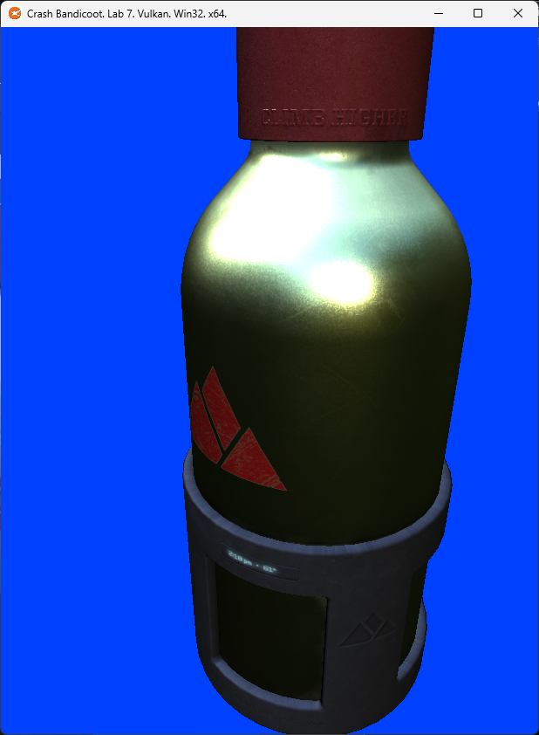
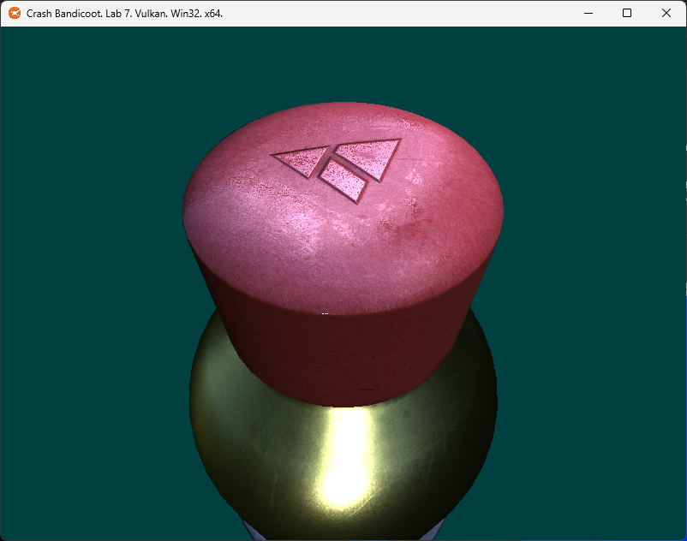
Once you get the PBR shader running, the difference in quality should leap out at you. Metal should look like metal, plastic like plastic. Even the painted logos on the metal bottle will react differently than the bottle itself.
This is the current state of the art as far as real-time materials go. You now know what it takes to re-create some of the highly realistic materials seen in commercial engines like Unreal Engine and other private AAA game engines. (Ex: Frostbite, Rage, Id Tech, Cry Engine, and many more!)
If you open the model in Blender and turn on the material view, you will notice it looks much closer to what you have now. It won’t be exactly the same (since Blender has multiple point lights to better illuminate the scene). It also uses a different IBL image by default. However, it will be MUCH closer than what you had with classic materials. If you want to see the flexibility of PBR, try some different test environments from the links in the README found in the PBR IBL ENV folder. (Watch how the bottle surface adapts to different surroundings)

LAB CHECKPOINT | MANUAL COMMIT | DO NOT SKIP
To receive credit for your assignments, you must manually commit to your Repo 4 times (Once at the end of each Part/Section). If you skip this commit (or disable auto commits) you will not receive credit for the previous section.
- Change the lab’s Title Bar so it says where you are in the lab.
  - For Example: “John Smith – Lab 1 – Part 1 Complete”
- Take a Screenshot of the lab window running showing your work. (Windows Key + Shift + S)
- On Windows the screenshot is in your clipboard, open MS Paint and (Ctrl + V) to load it in.
- Save the image with the same name as your title bar in the root folder of this repository.
- Open GitHub Desktop for this repo. You should see the new image as a pending change.
- Create a commit message with the same name as the title bar & commit your changes.
If this section is not perfect but you need to continue forward, you must still do this to get partial credit!

Summary
Congratulations! You have reached the end of 3DCC and have completed all the lab assignments. Even if you found this a struggle, our hope is your understanding of the subject has increased significantly. If you enjoyed the process or are just curious to know more, be happy to know this is just the tip of the iceberg when it comes to real-time computer graphics!
If you are thinking about this field as a career or even just wanting the option to apply for graphics programmer positions in the future, I would recommend trying the following after the course:
- Render a 3D cube/sphere model around the camera and use the environment maps to draw a Skybox.
- Adapt this code to support multi-material 3D models like the famous Sponza Level.
- Once you have that working, read about cascaded shadow maps and integrate them into Sponza.
- Load up a GLTF model that comes with skinned animation data and animate it in Spinoza.
- At that point I suggest investigating deferred lighting techniques or hardware raytracing.

Regardless of pursuing more graphics or not, learning Vulkan as an undergrad student is no joke. Your general programming and debugging skills should have bumped up another notch. Be proud of yourself!

Resources
If you want to be a programmer, you must learn to read (and eventually write) API documentation. Period. In this section I have included links to said documentation and some handy reference books. Have them open, use them.

Vulkan API
https://vulkan.lunarg.com/doc/view/latest/windows/apispec.html
https://www.khronos.org/files/vulkan11-reference-guide.pdf
ebooks.fullsail.edu (if the link does not work directly, copy it to your browser)
https://learning.oreilly.com/library/view/vulkantm-programming-guide/9780134464701/
https:/github.com/SaschaWillems/Vulkan (will not transfer directly, but you can study the code for some insight)
https://github.com/KhronosGroup/Vulkan-Guide (nice overview of more specific resources)

HLSL High Level Shading Language
https://docs.microsoft.com/en-us/windows/win32/direct3dhlsl/dx-graphics-hlsl-reference
Note: The above docs often refer to Direct3D APIs. Modern Vulkan can also use the language. You should just study the syntax of the language when using it with Vulkan as other things like compiling are done differently.
https://shadered.org (opensource HLSL & GLSL shader IDE, excellent for learning about modern shaders)
https://docs.microsoft.com/en-us/visualstudio/designers/shader-designer?view=vs-2019 (Visual Shader Designer)
Note: The VS Shader Designer is handy for prototyping complex shaders once you are more familiar with HLSL.

Gateware
We will be using this API occasionally throughout these assignments for simplicity’s sake. Gateware is a powerful cross-platform API often contributed to by students here at Full Sail just like you. (Designed for 3D Engine builders)
https://gateware-development.gitlab.io/gcompiler/index.html (Official Documentation)
Tip: use the “--->” triple-dash operator on any Gateware proxy to have intellisense show you the actual arguments.

FAQ
- How do I know if I am using the Vulkan API correctly?
  - Aside from reading the docs and making sure the code compiles, we have enabled run-time debug output in the Vulkan API. Be sure to pay close attention to the console window when running the program. Any non-fatal mistakes you make will be reported by the Vulkan validation layer and printed there.
- Visual Studio doesn’t seem to be detecting the errors in my shaders, how am I supposed to code like this?
  - Carefully. Believe it or not it was not so long ago that things like intellisense, syntax highlighting and auto complete were not a common thing, especially in shader languages!
  - The way to know if your shader will compile is to… compile it! (right?) Shader languages must be compiled into machine instructions just like C++. If you study the code that loads the shaders you will see that compiling is part of that process.
  - Vulkan uses a binary intermediate language called SPIR-V that higher level shader languages like HLSL and/or GLSL must be compiled into. If there are any issues when converting your code to SPIR-V the shaderc compiler will note the error and I added code to print it to the console. Keep your eyes on it.
  - It is possible to have visual studio compile your HLSL code - but the output is not compatible with Vulkan, and it cannot compile Vulkan-specific features like push constants. Once your shaders get complex, I recommend using a dedicated shader IDE like ShaderEd.
- I have no compiler errors or run-time errors, yet nothing seems to be drawing. What do I do now?
  - Check over your code carefully to ensure you did not miss anything obvious such as having the wrong shader or geometry assigned to a pipeline. (or just setting up your vertex data wrong)
  - Problems like this can be difficult to track down, mainly because your C++ code cannot really see what is happening on the GPU. You can download a third-party tool called RenderDoc to dig much deeper.
  - If you are still lost, talk to an instructor. We can often point you in the right direction or help you make sense of the error messages you encounter until you get more comfortable dealing with them yourself.
- Is possible to do these assignments without Gateware? I prefer to do things from the ground up.
  - Technically yes, practically no. While someone (Derrick Ramirez) did originally have to write the Vulkan interface to Gateware, setting up a modern Graphics API like Vulkan or Direct3D12 from scratch takes a substantial amount of time. It’s just something we don’t have enough time for in a one-month course.
  - If you still really want to learn how to initialize a 3D API with no dependencies, there are plenty of online resources out there (including a few of my own) on how to do exactly that once you complete this course.

section E | 150% - BONUS SECTION - MULTI-MATERIAL/MESH 3D Models (SPONZA)

OVERVIEW
This section is completely optional, I have not even done it myself yet. I was just brainstorming what might be fun to try if you finished the class early and are looking for something else to push your understanding.
I don’t really expect anyone to complete all of this, but if you get a decent way into it let me know. Probably worth a Course Director award and possibly a Advanced Achievement award depending on how far you get.

task E1
Load the famous Sponza model or another fancier GLTF test model instead of the bottle.

task E2
Only the first part of it may draw since we are only using the first mesh.
If everything in the model is drawing it may be only a single mesh model. If you try to draw this Chess Board, you will probably fail to render most of the model. (It’s a multi-mesh model)

task E3
Adjust the code to draw all the meshes in the model. (Requires Storage Buffers + Instancing from lab 4)

task E4
The textures will be wrong since we are only using the first material.

task E5
Adjust the code to apply all the materials in the model.

task E6
Adjust the shaders to discard a pixel if its alpha is less than 0.5. Implement full Transmission materials if you want an extra challenge. (a.k.a Transparent surfaces)

task E7
Consider the lack of shadows and how to fix it. (Shadow Maps or Raytracing)

